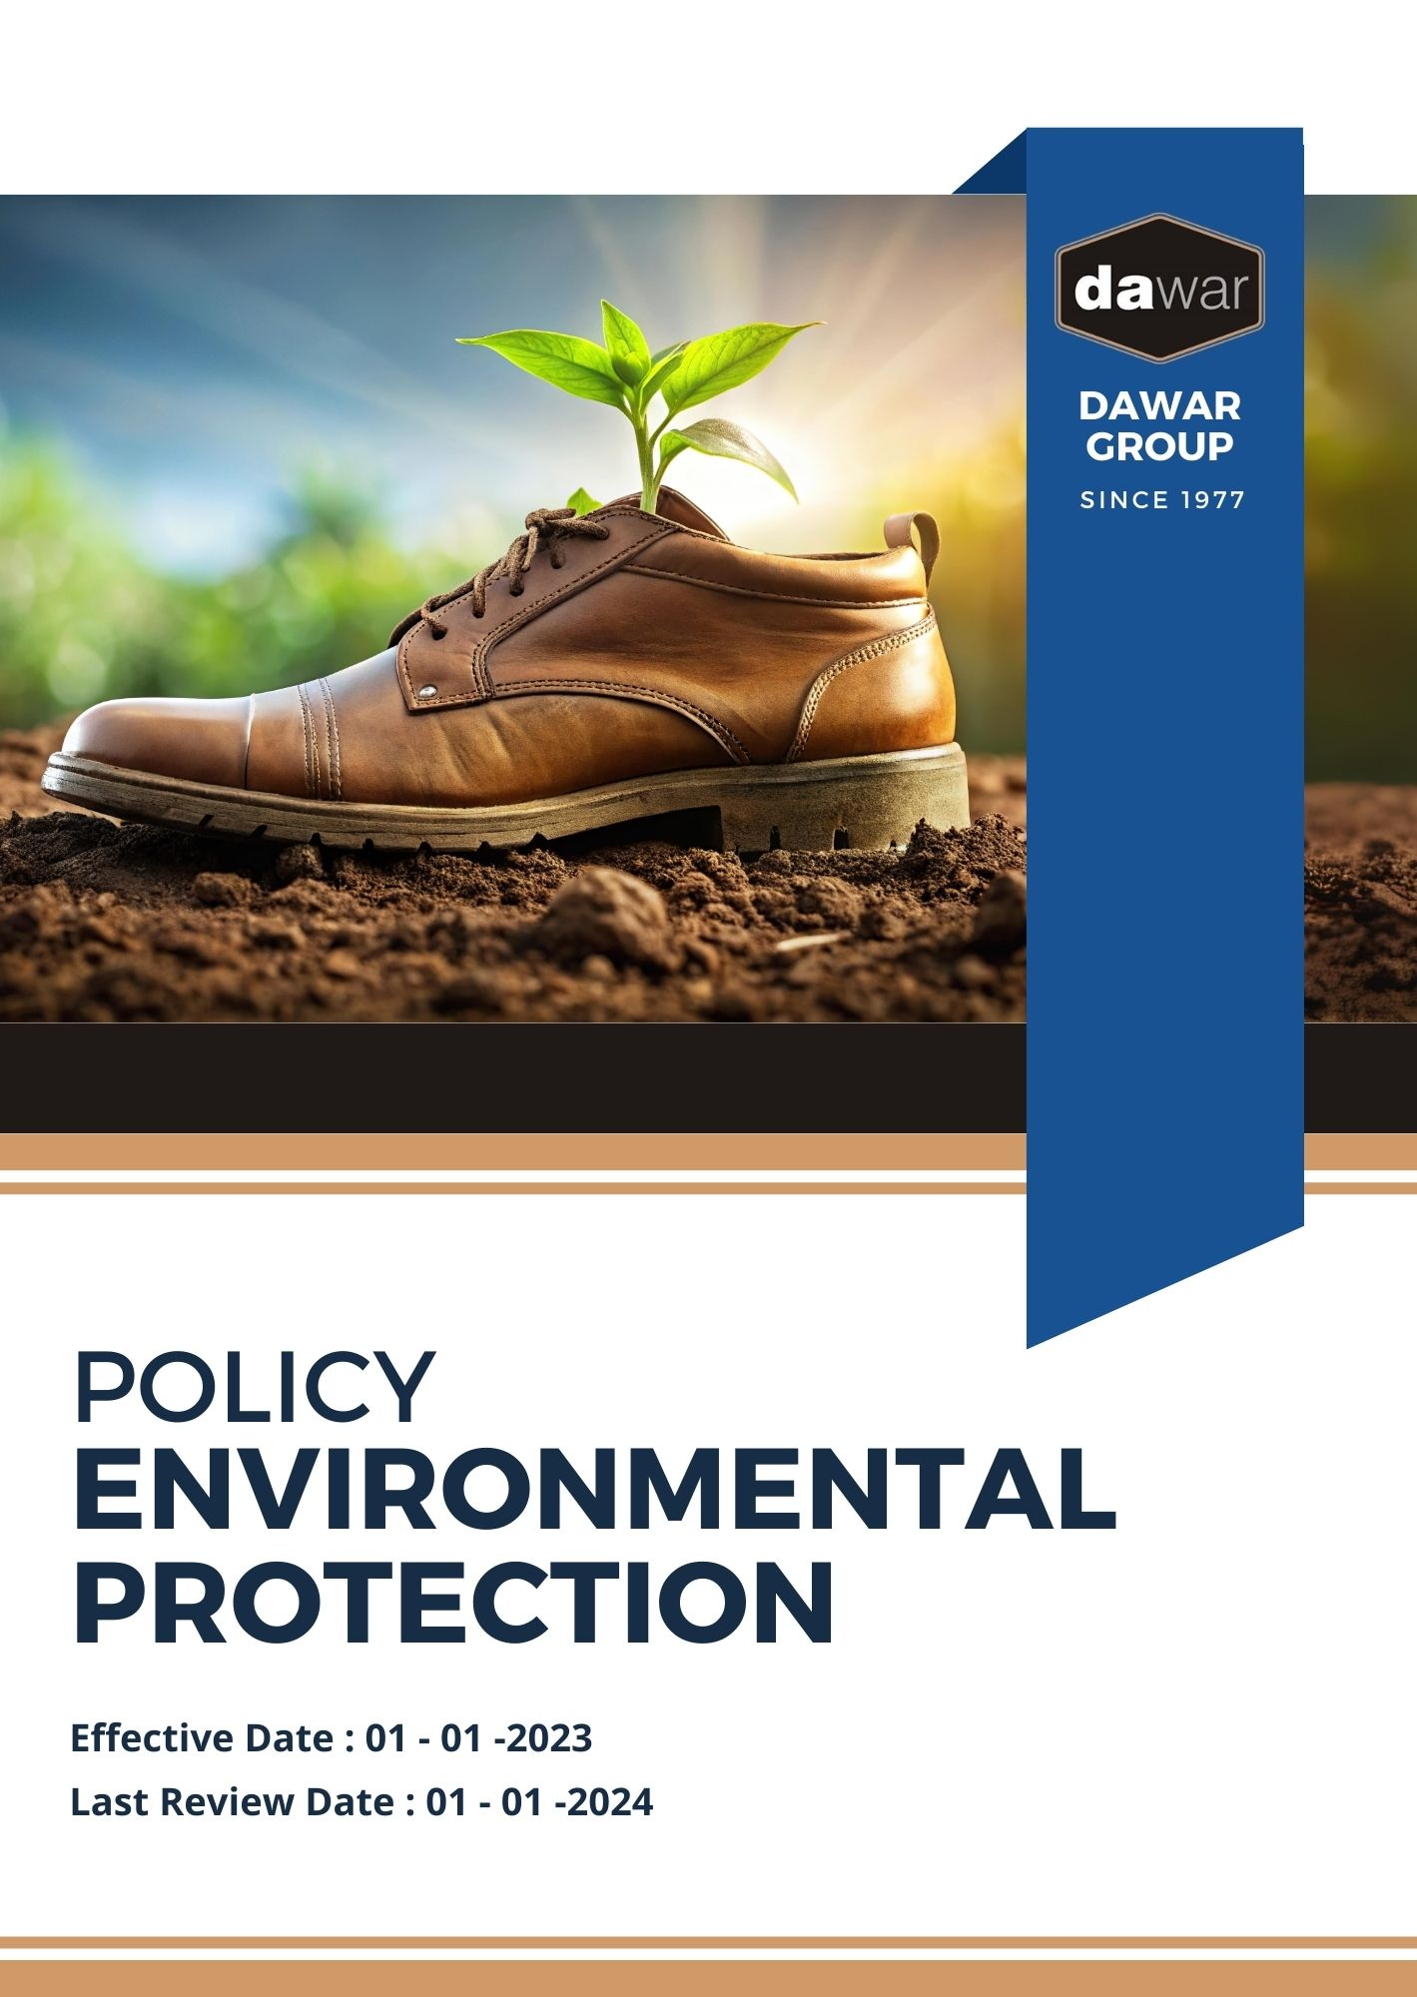

Table Of Contents

A. Why It Matters 3
B. The Dawar Group Approach 3
C. Scope 3
D. Expectations 3
E. Dawar Group’s Sustainability Commitments: 4
F. Governance and Allocation of Responsibilities 7
G. Reporting Section 8
H. Covered SDGs 9
I. Review Mechanism 9
J. Employee Acknowledgement Form: Environmental Protection Policy 10

Why It Matters
Dawar Group is committed to preserving the environment, promoting sustainable practices across our operations, and extending this commitment throughout our supply chain. This dedication is not only a crucial social responsibility but also adds value to our business, customers, stakeholders, and employees.

The Dawar Group Approach
It is the policy of Dawar Group to operate in a manner that protects the environment and promotes the sustainable use of natural resources. This includes responsible sourcing, water conservation, efficient use of raw materials, and clean energy utilization, while integrating our eco-friendly mindset throughout the value chain.

We set annual goals, develop necessary capabilities, and allocate appropriate resources to achieve this policy through innovation, operational efficiency, and alignment with Dawar Group's sustainability objectives.

Scope
This policy applies to all employees, stakeholders, contractors, partners, customers, contractual workers, and anyone acting on behalf of the following sites:

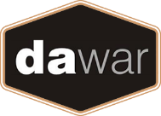 | Dawar Group
 | Address: Near Bapu Asaram Asaram, 12.5 Km, Agra-Delhi Road, Sikandra, Agra-282007 (India)
 | https://www.dawargroup.com/about-us/

Expectations
- Environmental Compliance
Dawar Group complies with all applicable environmental laws and regulations. We foster employee engagement, set performance standards, and use an Environmental Management System to drive compliance and continuous improvement, including:
- Implementing water usage reduction and recycling measures in all operations;
- Adopting renewable energy sources and implementing energy efficiency measures to reduce our carbon footprint;
- Setting and achieving greenhouse gas (GHG) reduction targets through various sustainability initiatives;
- Minimizing waste generation and promoting recycling throughout our operations and supply chain;
- Supporting biodiversity through sustainable sourcing practices and conservation efforts;
- Managing local and unexpected contamination effectively;
- Reducing air pollution by adopting advanced processing technologies and emissions control measures;
- Managing raw materials and chemicals responsibly, including the use of eco-friendly dyes and chemicals;
- Developing products that have minimal environmental impact during their use phase;
- Creating biodegradable and compostable products to reduce environmental impact at the end of their lifecycle;
- Ensuring customer health and safety by adhering to stringent quality control and safety standards;

Dawar Group’s Sustainability Commitments:
- Establishes 2022 as the Baseline year for measuring progress and achievements in our sustainability initiatives.

- Water Usage Reduction and Recycling:
- We aim to achieve a 15% reduction in water consumption and 40% water recycling by 2026, through the implementation of a smart water management system and advanced reverse osmosis filtration technology.
- We plan to optimize our processes, reducing water consumption by 15% through the adoption of automated water-saving technologies by 2026.
- We intend to implement a rainwater harvesting system using state-of-the-art collection tanks, meeting 20% of our water needs from this sustainable source by 2026.

- Renewable Energy and Energy Efficiency:
- We aim to attain 40% renewable energy usage and improve energy efficiency by 30% by 2026, through the installation of solar photovoltaic panels and upgrading to high-efficiency LED lighting.
- We plan to transition 100% of our process heating to biomass-based systems, utilizing waste materials as fuel by 2026.
- We intend to achieve a 30% reduction in energy consumption by implementing intelligent building management systems across all production lines by 2026.

- Greenhouse Gas (GHG) Reduction:
- We aim to reduce Scope 1 and 2 GHG emissions by 15% by 2026, by switching to electric forklifts for internal transportation and optimizing production processes using energy-efficient machinery.
- We plan to reduce our Scope 3 emissions by 15% by 2026, through optimized logistics and the implementation of a supplier engagement program focused on emissions reduction.
- We intend to achieve carbon neutrality for our administrative operations by 2026, through a combination of emissions reduction initiatives and investment in verified carbon offset projects.

- Waste Minimization and Recycling:
- We aim to achieve 30% waste recycling and reduce total waste generation by 15% by 2026, through the implementation of a comprehensive waste-to-energy system and developing innovative applications for waste.
- We plan to develop a closed-loop manufacturing system, reintegrating 20% of waste back into our production cycle by 2026.
- We intend to reduce packaging waste by 30% by 2026, through the implementation of biodegradable packaging materials and reusable packaging solutions.

- Biodiversity Support:
- We aim to increase sustainable sourcing area by 25% and establish 7 biodiversity conservation projects by 2028, by partnering with local communities to promote sustainable practices and creating wildlife corridors.
- We plan to establish a seed bank preserving 40 native varieties by 2026, supporting genetic diversity and resilience in our sourcing.
- We intend to implement agroforestry practices on 15% of our sourcing land, enhancing biodiversity and providing additional income streams for local communities by 2026.

- Air Pollution Reduction:
- We aim to reduce particulate matter emissions by 25% and volatile organic compounds (VOCs) by 30% by 2026, through the installation of electrostatic precipitators and switching to low-VOC processing chemicals.
- We plan to eliminate all ozone-depleting substances from our operations by 2026, through the adoption of natural refrigerants and eco-friendly cleaning processes.
- We intend to reduce odor emissions by 55% by 2026, through the installation of bio-filtration systems and optimization of waste treatment processes.

- Responsible Raw Material and Chemical Management:
- We aim to achieve 70% use of eco-friendly dyes and chemicals and increase sustainable raw material sourcing by 50% by 2026, through partnerships with certified suppliers and the development of in-house sustainable alternatives.
- We plan to transition to 100% organic sourcing for our premium product line by 2026, working closely with suppliers to support organic practices.
- We intend to develop a proprietary eco-friendly softener, reducing chemical usage by 60% in our processes by 2026.

- Environmentally Friendly Product Development:
- We aim to develop 7 new eco-friendly products with 55% lower environmental impact by 2026, by investing in R&D and conducting lifecycle assessments.
- We plan to launch a range of biodegradable alternatives to single-use plastics, capturing 7% of the market by 2026.
- We intend to develop construction materials with 25% lower carbon footprint by 2026.

- Biodegradable and Compostable Products:
- We aim to ensure 65% of our product range is fully biodegradable or compostable by 2026, by developing new biodegradable polymers and conducting accelerated biodegradation testing.
- We plan to establish a take-back program for our products, achieving a 25% return rate by 2026.

- Customer Health and Safety:
- We aim to achieve zero product recalls and 100% compliance with international safety standards by 2026, through AI-powered quality control systems and enhanced traceability.
- We plan to implement a real-time traceability system allowing customers to track their products from production to shelf by 2026.

- Promoting Sustainable Consumption:
- We aim to increase market share of sustainable products by 35% and educate 1.5 million consumers on the benefits by 2026, through digital marketing campaigns and partnerships with eco-conscious retailers.
- We plan to establish partnerships with 40 major retailers to create dedicated "Sustainable Products" sections by 2026.
- We intend to launch a consumer education app providing information on environmental benefits and product care, reaching 1.5 million active users by 2026.

- Eco-Conscious Community:
- We empower our suppliers and customers by providing training and resources to utilize advanced technologies such as smart meters, EMS, IoT sensors, and waste tracking software, aiming for significant reductions in energy consumption, water usage, GHG emissions, and waste generation by 2026.

Governance and Allocation of Responsibilities
The governance structure at Dawar Group for the Environmental Protection Policy ensures clear allocation of responsibilities to drive accountability and continuous progress towards our environmental objectives. Key governance roles include
- Board of Directors:
- Oversees the overall environmental strategy and approves long-term sustainability goals.
- Ensures alignment of environmental initiatives with business objectives and stakeholder expectations.

- Environmental Sustainability Manager:
- Implements and manages the Environmental Sustainability Policy.
- Reports on environmental performance and progress towards targets.

- Environment Preservation Committee (EPC):
- Oversees day-to-day environmental operations and compliance.
- Coordinates with various departments to integrate sustainability practices.

- All Employees:
- Adhere to the policy and participate in environmental training.
- Report any environmental concerns or violations to the Environmental Management Team.

Reporting Section
At Dawar Group, we emphasize transparent and effective reporting to ensure our environmental performance is communicated clearly to all stakeholders, including employees, customers, investors, and regulatory bodies. Our reporting mechanism is structured to deliver accurate, timely, and relevant information. The key components are as follows:
- Environmental Performance Metrics:
- Conduct Annual evaluations of critical environmental indicators, including energy consumption, water usage, waste generation, and greenhouse gas emissions.
- Employ advanced monitoring technologies, such as smart meters and automated water sensors, to ensure real-time and precise data collection.
- Prepare and review monthly reports that compare performance against established baselines and targets outlined in our environmental Protection policy.

- Annual Sustainability Report:
- Publish a detailed annual sustainability report that offers a thorough overview of our environmental initiatives, achievements, challenges, and future objectives.
- Highlight successful projects, such as our energy-efficient lighting upgrades and waste-to-energy initiatives.
- Engage an independent third-party environmental auditor to verify the accuracy and reliability of the report, enhancing credibility and transparency.

- Environmental Incident Reporting:
- Implement a robust system for reporting and managing any environmental incidents or near-misses.
- Provide monthly summaries of incidents, including detailed root cause analyses and corrective actions taken to prevent recurrence.

- Community and Stakeholder Engagement Reports:
- Document our environmental education programs and community outreach efforts, detailing the number of participants and the impact of these initiatives.
- Collect and compile stakeholder feedback on our environmental performance and initiatives, using it to inform continuous improvement.

Covered SDGs
 | 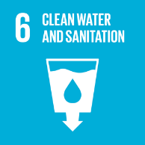 |  |  |  | 

Review Mechanism
The Environmental Safety Office is responsible for overseeing the implementation and review of this policy. This policy will be reviewed annually to ensure its effectiveness and relevance. Updates and changes will be communicated to all stakeholders as necessary.

(Signature)
Approved By:
Designations:
Next Review Date: 01-01-2025

Employee Acknowledgement Form: Environmental Protection Policy

I, acknowledge that I have received, read, and understood Dawar Group Environmental Protection Policy. I am aware of the company's commitment to protecting the environment, promoting sustainable jute cultivation and processing, and extending our eco-friendly mindset across the entire supply chain.
I understand my role in supporting this policy, including complying with all applicable environmental laws and regulations, participating in sustainability initiatives, and contributing to the company's environmental goals. I agree to adhere to sustainable practices in my daily work, report any environmental concerns, and contribute ideas for continuous improvement.
By signing below, I confirm my commitment to upholding Dawar Group Environmental Protection Policy and supporting the company's sustainability efforts.

Employee Name: ______________________
Date: _______________
Employee Signature: ____________________

